For Immediate Release March 20th, 2019
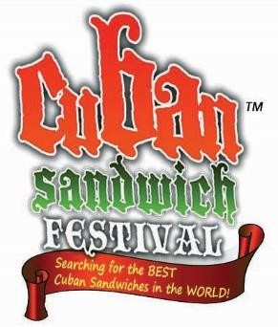
Info: Jolie Gonzalez-Padilla
Info: Jolie@iLOVECubanSandwiches.com or (813) 407-6866

FORD named PRESENTING SPONSOR of 8th annual Intl Cuban Sandwich Festival; set for 2 Days in Ybor City!

Tampa, Florida: Latin Times Media., Inc. is excited to announce WELCOME FORD as the Presenting
SPONSOR and the OFFICIAL Auto sponsor of the 8th Annual Intl Cuban Sandwich Festival which will be held in Ybor City, Florida. Festival is set for:
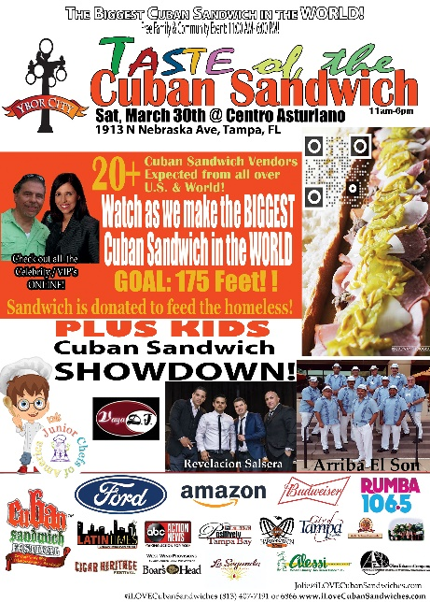
IN YBOR CITY!
Day 1: Saturday, March 30th, 2019: Taste of the Cuban Sandwich @ Centro Asturiano: 1913 N. Nebraska Ave (Nebraska/Palm) in Tampa, FL.

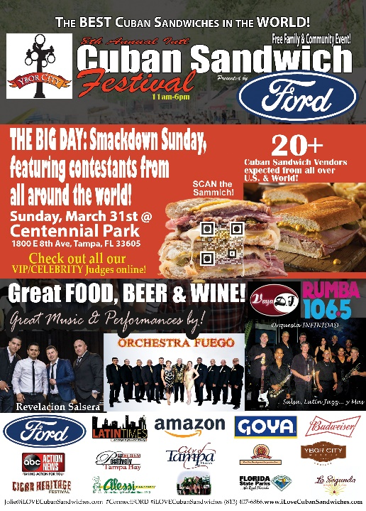
Enjoy the Kids Cuban Sandwich SHOWDOWN, visit all the Cuban Sandwich Vendors, enjoy LIVE MUSIC and Dance Performances! We will also be attempting to make the BIGGEST Cuban Sandwich in the World, breaking Kissimmee’s record with our goal of 175 Ft. This sandwich will then be donated to feed the Metropolitan Ministries to feed the homeless!

Day 2: Sunday, March 31st, 2019 THE BIG DAY: 8th Annual Intl., Cuban Sandwich Festival, presented by FORD @ Centennial Park: 1800 E. 9th Ave in Tampa

Enjoy THE BIG DAY at the Festival, visit all the Vendors with 20+ of the competing to see who makes the BEST Cuban Sandwich in the World! Enjoy LIVE Music and Dance performances! BEER and Wine will be sold.

“We are so excited and honored to be welcome FORD as our Presenting Sponsor for this exciting FREE COMMUNITY event the Cuban Sandwich Festival is a festival and contest to find THE BEST CUBAN SANDWICHES IN THE WORLD! Guests enjoy great FOOD and music by official DJ: Johnnie Rivera -Vaya DJ plus LIVE cultural music and dance performances on Stage including Revelacion Salsera, Arriba El Son, Orchestra Fuego, Orquesta Infinidad and MORE!

VIEW our other sponsors, a list of contestants and our VIP/Celebrity Judges at www.TheCubanSandwichFestival.com

Do you want event info or do you think you make the BEST Cuban Sandwich? Or Do you know someone that makes the BEST Cuban Sandwich in Central Florida? Jolie@iLOVECubanSandwiches.com or call (813) 407-6866 or 7191. www.TheCubanSandwichFestival.com

For more info on your local Ford dealers, visit www.BuyFordNow.com
#ConnectFord #FORDLovesCubanSandwiches #iLOVECubanSandwiches

